# Operational Concept Description (OCD)

**Farmworkers Safety System**

**Team 09**

|  |  |
| --- | --- |
| **TEAM MEMBER NAME** | **ROLES** |
| **Juan Andrade** | Project Manager  Life Cycle Planner  Developer |
| **Theerapat Chawannakul** | System Architect  Developer |
| **Fereshteh Khorzani** | Independent Verification and Validation  Quality Focal Point |
| **Vahagen Sinanian** | Operational Concept Developer  Developer |
| **Basir Navab** | Life Cycle Planner  Developer |
| **Basir Navab** | Life Cycle Planner  Project Manager |
| **David Tasky** | Independent Verification and Validation  Quality Focal Point |

**April 28, 2017**

# Version History

| Date | Author | Version | Changes made | Rationale |
| --- | --- | --- | --- | --- |
| 10/12/16 | Vahagen Sinanian | 1.0 | Initial version | Draft for FCR ARB |
| 10/17/16 | Vahagen Sinanian | 1.1 | * Updated the benefit chain diagram * Updated capability goals table * Completed Level of service table | * Imitative values on benefit chain diagram were wrong. * Content of the table have been corrected. * Level of service table was not completed |
| 12/05/16 | Vahagen Sinanian | 2.0 | * Updated the program model * Updated the LOS table | * Added system administrator to the Program Model table * Corrected the Level of Service Goals |
| 02/19/17 | Vahagen Sinanian | 3.0 | * Updated System Type * Updated Team members table | * Changed the system type to web application * Removed the team members who left the team and added the new members. * Updated the roles and responsibilities of all members according to their roles assigned for Spring 2017 class. |
| 04/28/17 | Vahagen Sinanian | 4.0 | * Updated System Boundary diagram | * Added Bitly API to the diagram as a new API being used by the team for Farmworker Safety System |

# Table of Contents

Operational Concept Description (OCD) i

Version History ii

Table of Contents iii

Table of Tables iv

Table of Figures v

1. Introduction 1

1.1 Purpose of the OCD 1

1.2 Status of the OCD 1

2. Shared Vision 2

2.1 Benefits Chain 3

2.2 System Capability Description 4

2.3 System Boundary and Environment 5

3. System Transformation 6

3.1 Information on Current System 6

3.2 System Objectives, Constraints and Priorities 6

3.3 Proposed New Operational Concept 9

3.4 Organizational and Operational Implications 10

# Table of Tables

Table 1: The Program Model 2

Table 2: Level of Service Goals 7

Table 3: Relation to Current System 8

# Table of Figures

Figure 1: Benefits Chain Diagram of Farmworker Safety System 3

Figure 2: System Boundary of Farmworker Safety System 5

Figure 3: Element Relationship Diagram of Farmworker Safety System 7

Figure 4: Business Workflow Diagram of Farmworker Safety System 8

### Introduction

#### Purpose of the OCD

This document provides detailed information about Farmworkers Safety System Critical shareholders’ shared vision. Critical stakeholders of Farmworkers Safety System are as following: Senator Dean Florez and Faith Florez as owners of the project, developers, maintainers, farmworker, contractors, and farmers.

#### Status of the OCD

In version 4.0 of the Operational Concept Design document we have updated the System Boundary diagram by adding the Bitly API which is being used for Farmworker Safety System Application.

### Shared Vision

Table 1: The Program Model

|  |  |  |  |
| --- | --- | --- | --- |
| **Assumptions**  Farmers have phones and Internet connectivity; They can use their phones at work.  They have nearby access to water and shade.  Farmers want to improve working conditions.  Contractors and farmers are obligated to provide safety for farmworkers. | | | |
| **Stakeholders** | **Initiatives** | **Value Propositions** | **Beneficiaries** |
| Developer  System Administrator  Maintainer  Farmworker  Contractors  Farmers  Regulators | * Develop the system * Manage data and content on system. * Keep the system up and running * Setup a profile with correct phone number and accurate location * Update locations of farmworkers based on their farm assignments * Manage farmworkers through profiles and provide feedback * Set standards for farmer safety | * Provide temperature based notifications. * Educate farmers and improve their quality of life. * Improve productivity of farmworkers. | * Farmworkers * Consumers of farm products * Farmers and contractors |

#### Benefits Chain

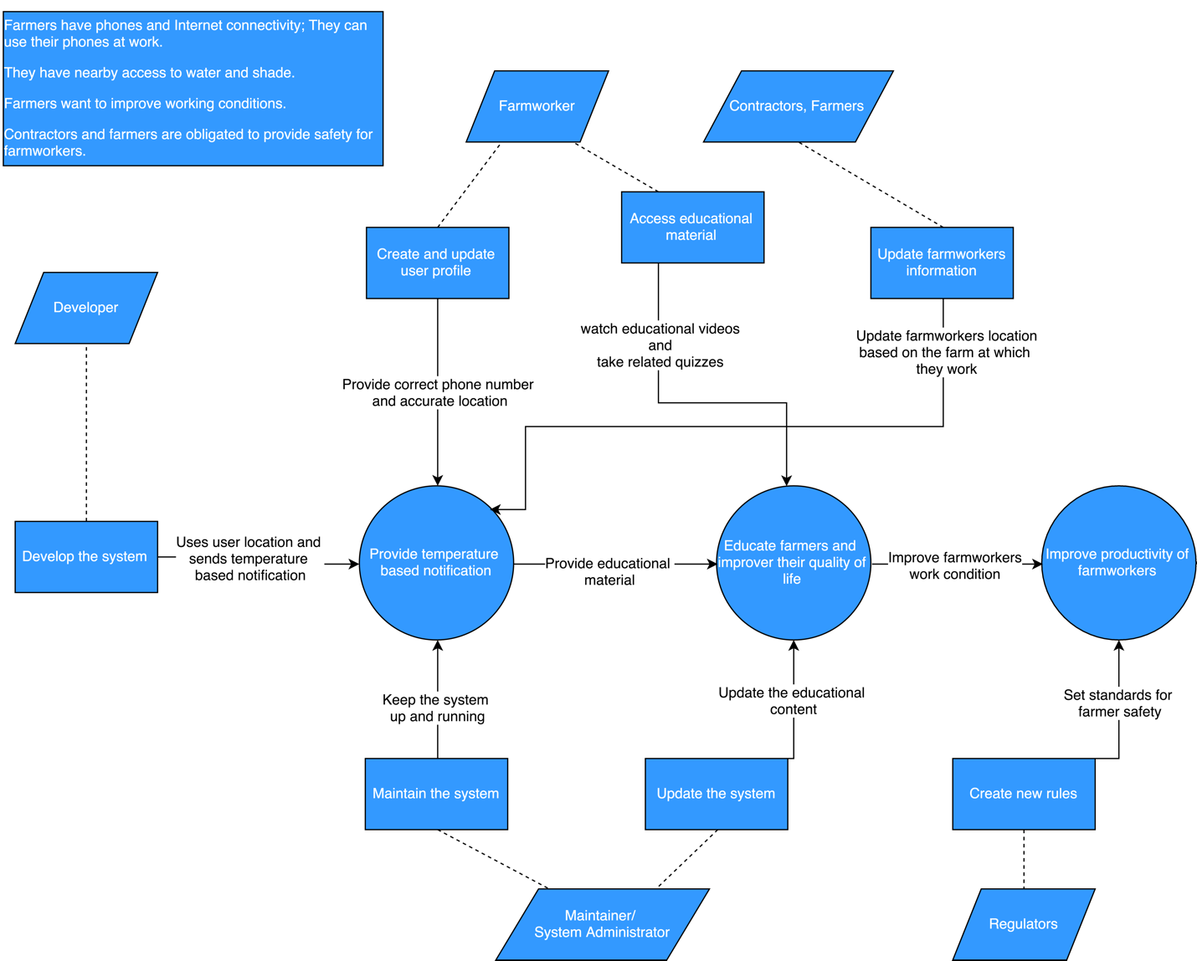

Figure 1: Benefits Chain Diagram of Farmworker Safety System

#### System Capability Description

##### Type of system:

Farmworkers Safety System is a responsive web application and currently there is no competitive system available.

##### Target Customers:

Main customers for our system are farmworkers, contractors, and farmers.

##### Need or opportunity satisfied by the system:

* Prevent heat illness among the farm workers by notifying them of work conditions.
* Provide an educational platform
* Support CAL/OSHA compliance efforts

##### Compelling reason for the customer to buy/use the system:

1. **Consistency:** This system will programmatically check weather conditions at work locations to consistently notify farmworkers when the temperature reaches predefined thresholds.
2. **Long-term impact:** The educational content embedded in our system will help the farmworkers learn how to reduce and prevent heat illness. Education will foster lasting change.
3. **Designed with audience in mind:** Our system supports both English and Spanish languages; Therefore, farmworkers who don't speak English also can use it and gain the same benefits.
4. **Stakeholder value:** Farm Contractors and Farmers can monitor heat conditions and access advanced information including forecasts and historical weather data. The net effect is healthier farmworkers and higher productivity.

#### System Boundary and Environment

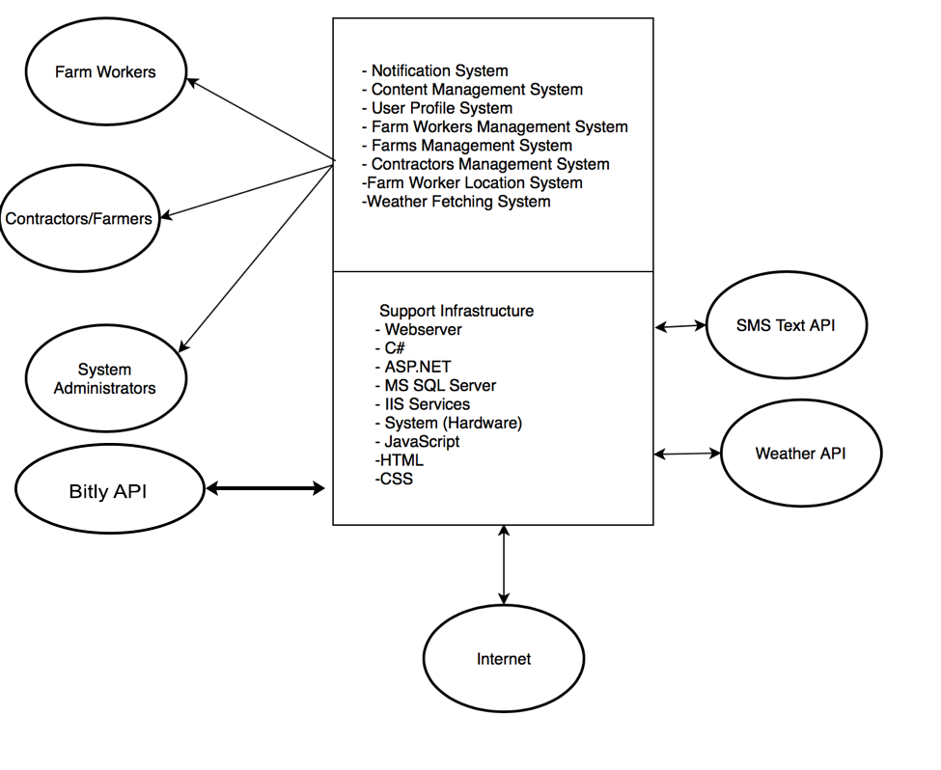

Figure 2: System Boundary of Farmworker Safety System

### System Transformation

#### Information on Current System

Currently there is no system and we are building this system from scratch.

##### Infrastructure

##### Artifacts

##### Current Business Workflow

#### System Objectives, Constraints and Priorities

##### Capability Goals

|  |  |
| --- | --- |
| **Capability Goals** | **Priority Level** |
| **OC-1:** Provide temperature based notification | 2 |
| **OC-2:** Provide educational content to educate the farmers in how to prevent heat illness | 3 |
| **OC-3:** Get farmers accurate location and correct phone number | 1 |
| **OC-4:** Update the farmworker location via SMS and the website. | 4 |
| **OC-5:** Farmworkers should be able to create emergency contact list | 5 |
| **OC-6:** Farmworkers should be able to send their location to emergency services. | 6 |

##### Level of Service Goals

Table 2: Level of Service Goals

Priority level scale:1-10 ( 1 is highest)

|  |  |  |
| --- | --- | --- |
| **Level of Service Goals** | **Priority Level** | **Referred WinWin Agreements** |
| **LOS-1:** The system shall be scalable to up to at least the 400,000 farmworkers in California. | 1 | WC_4156, WC_4159, WC_4184 |
| **LOS-2:** The system shall not be down for more than 24 hours in a month. | 2 | WC_4164, WC_4159 |
| **LOS-3:** The system shall have cross platform and cross system capability. | 3 | WC_4166, WC_4179 |

##### Organizational Goals

**OG-1:** Improve farmworkers quality of life.

**OG-2:** Educate farmworkers about the risks that they can face because of heat

**OG-3:** Notify farmers and farmworkers about work conditions

##### Constraints

1. Keep the data usage as low as possible for farmworkers who don't have data plans.
2. Find SMS and weather APIs that enable high-rate of calls at minimal cost.

##### Relation to Current System

There is no current system.

Table 3: Relation to Current System

|  |  |  |
| --- | --- | --- |
| **Capabilities** | **Current System** | **New System** |
| Roles and Responsibilities | N/A | N/A |
| User Interactions | N/A | N/A |
| Infrastructure | N/A | N/A |
| Stakeholder Essentials and Amenities | N/A | N/A |
| Future Capabilities | N/A | N/A |

#### Proposed New Operational Concept

##### Element Relationship Diagram



Figure 3: Element Relationship Diagram of Farmworker Safety System

##### Business Workflows

Tentative%20Potential%20Business%20Workflow.png

Figure 4: Business Workflow Diagram of Farmworker Safety System

#### Organizational and Operational Implications

Since there is no previous version of this system there is no changes to Organizational and Operational Implementations.

##### Organizational Transformations

##### Operational Transformations